IS 4990

Kurt Jensen, 2/22/2023

Lab #2

**Objectives:**

Deploy a container instance in Azure using the Azure portal.

**Procedure:**

1. Sign into azure.
2. Create a container instance in your resource group.
3. Enter the FQDN into your web browser.

**Complications:**

This lab was straight forward. I just followed the quick start, and everything worked perfectly with no complications.

**Conclusion:**

I created a container instance that runs on my webserver.

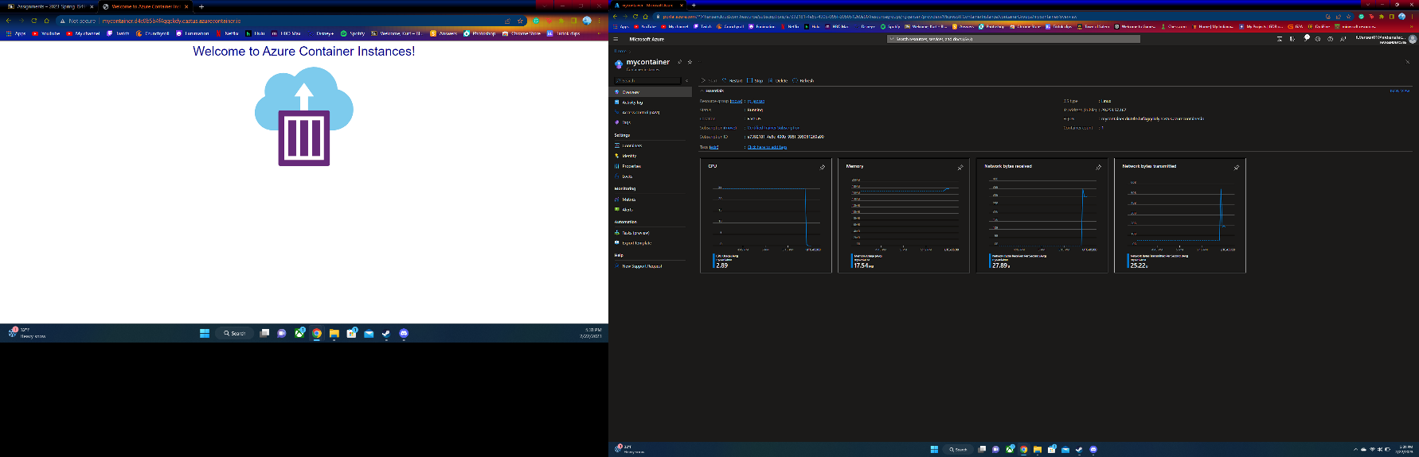**Screenshots:**